Ideation Phase
Empathize & Discover

Date | 27 October 2026
Team ID
Project Name | StaffSync
Maximum Marks | 4 Marks

Empathy Map Canvas:
Understand the needs, frustrations, and behaviors of HR personnel, managers and employees seeking efficient, transparent HR processes through a platform like StaffSync.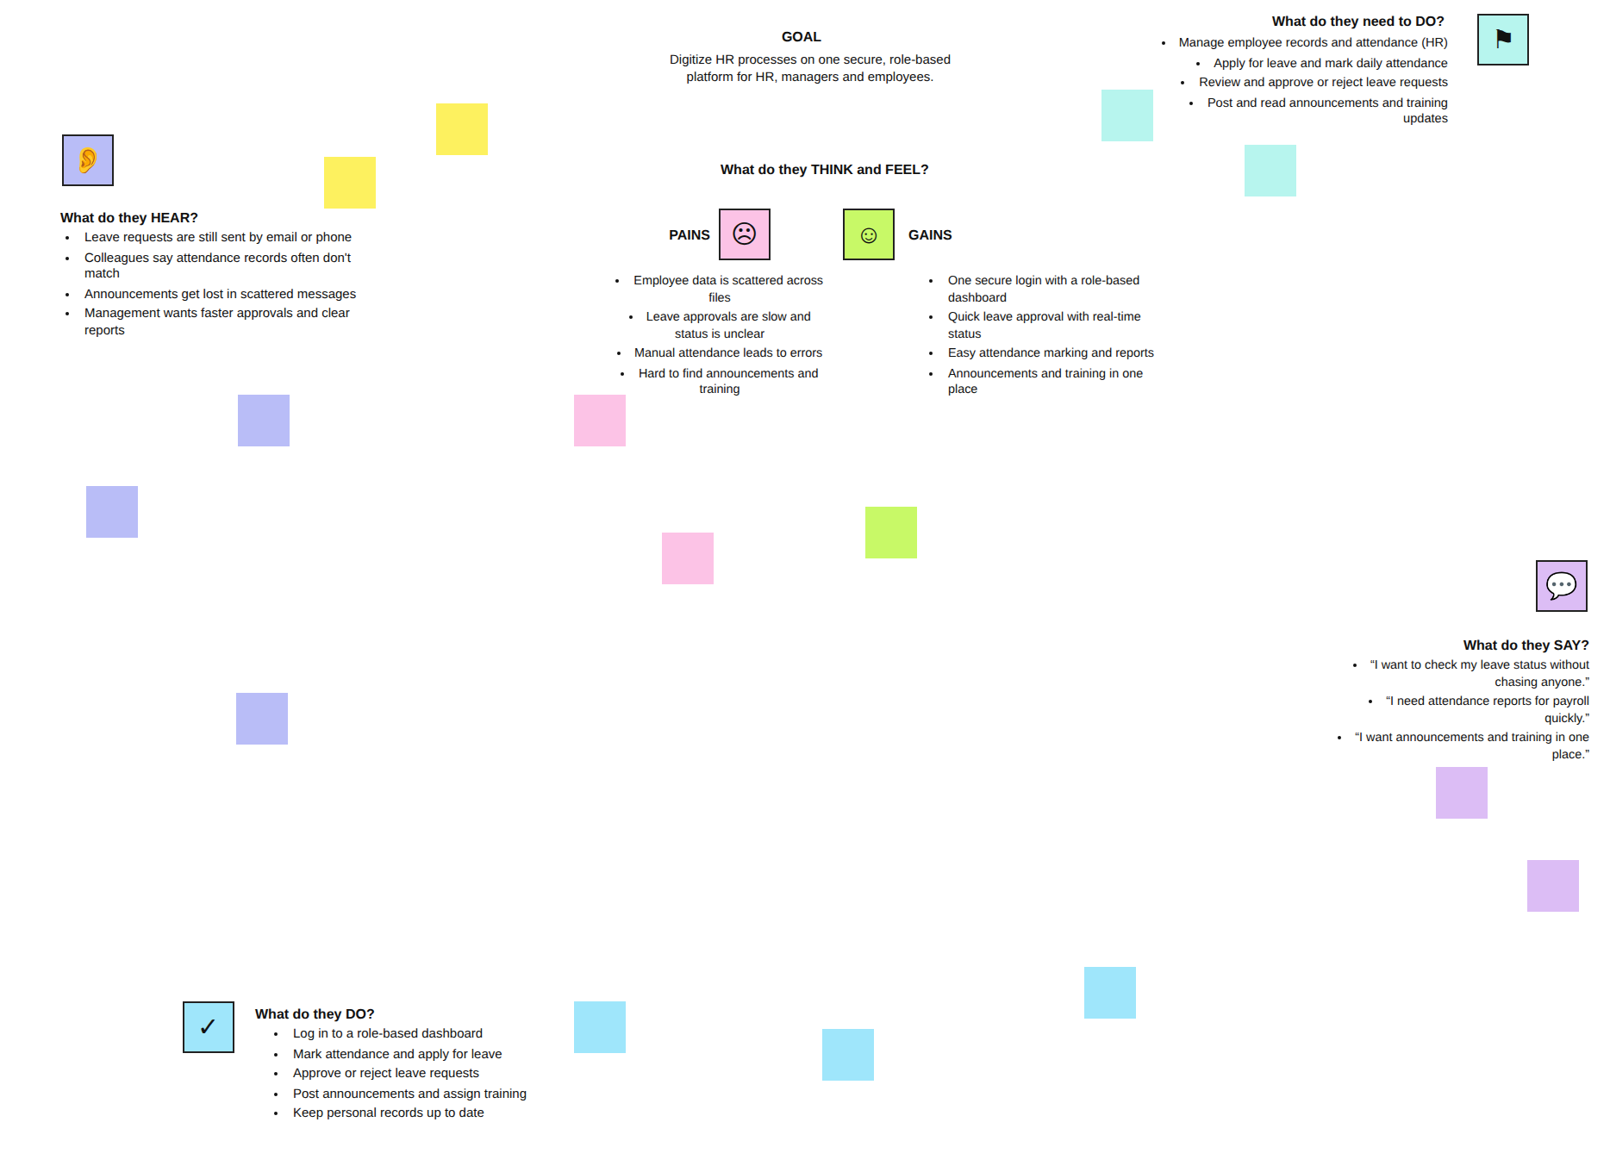

Reference: https://www.mural.co/templates/empathy-map-canvas

